CSE 564 Project 2 CRUD Assignment

Xiaoyu Zhang

1207639026

# ReadMe

1. Download and unzip the package **CRUD-GradeBook-xzhan320-Netbeans**
2. Run NetBeans IDE and click File -> Open Project. On folder selection page, open both **CRUDsrv-GradeBook-xzhan320-Netbeans** and **CRUDcli-GradeBook-xzhan320-Netbeans**.

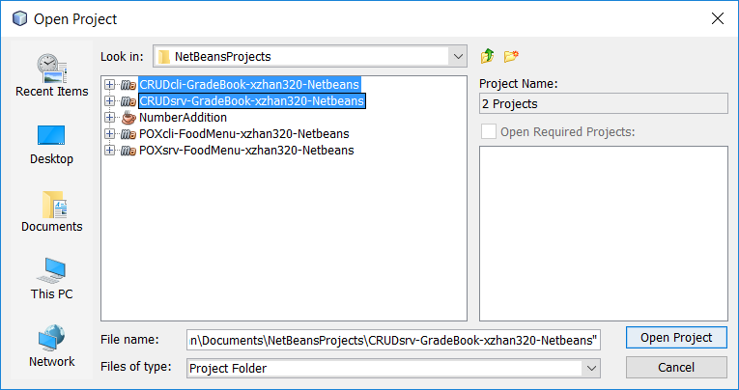

1. Direct to the server folder (CRUDsrv-GradeBook-xzhan320-Netbeans) and open **GradebookResource.java** file under CRUDsrv-GradeBook-xzhan320-Netbeans – Source Packages – com.myasu.crudsrv.gradebook.xzhan320.netbeans – GradebookResource.java

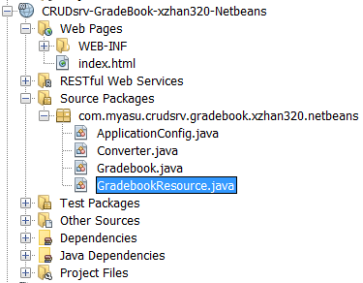

1. C:\Users\xzhan\Documents\Tencent Files\369937342\FileRecv\MobileFile\Image\}8G)4PY3GBZXE$2)~BT]%XW.pngClean build the server program by clicking the grey hammer button on the control panel.

(Display below the step 5)

1. Run the server program by clicking the green arrow button on the top right of the control panel.

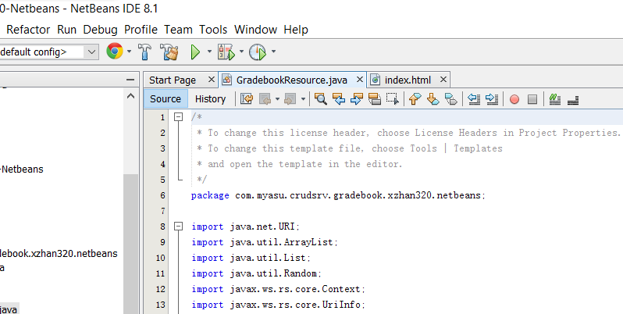

1. When prompt, choose **GlassFish Server 4.1.1** for deployment.



1. The output panel will show following message.

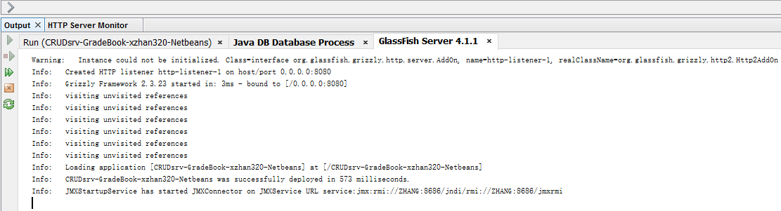

And a sample web page will pop up.

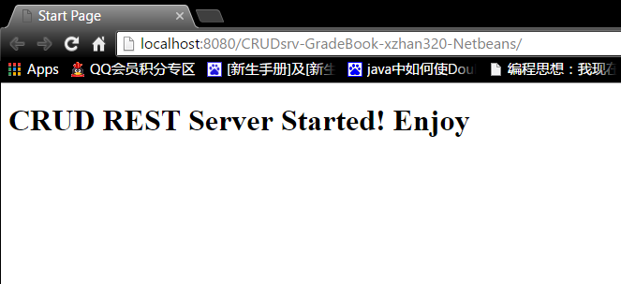

1. Now go back to Netbeans and direct to the client folder (CRUDcli-GradeBook-xzhan320-Netbeans) and open **Grading_REST_UI.java** file under CRUDcli-GradeBook-xzhan320-Netbeans – Source Packages – com.myasu.crudcli.gradebook.xzhan320.netbeans – Grading_REST_UI.java

C:\Users\xzhan\Documents\Tencent Files\369937342\FileRecv\MobileFile\Image\}8G)4PY3GBZXE$2)~BT]%XW.png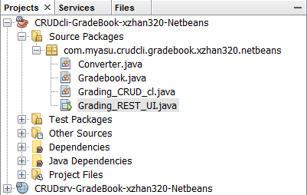

1. Once again, clean build and then run the client program by clicking the and button on the top right of the control panel.

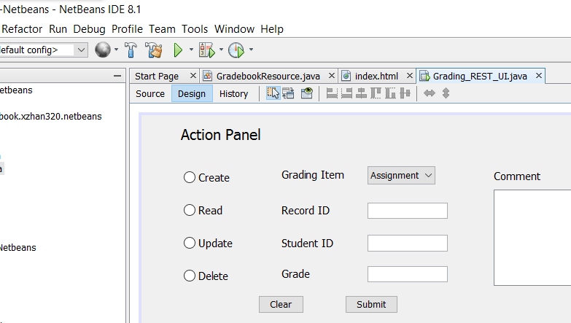

Choose com.myasu.crudcli.gradebook.xzhan320.netbeans.Grading_REST_UI as Main Class.

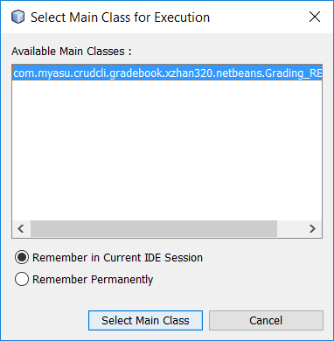

1. Now, you will see a GUI window pop up with following components:

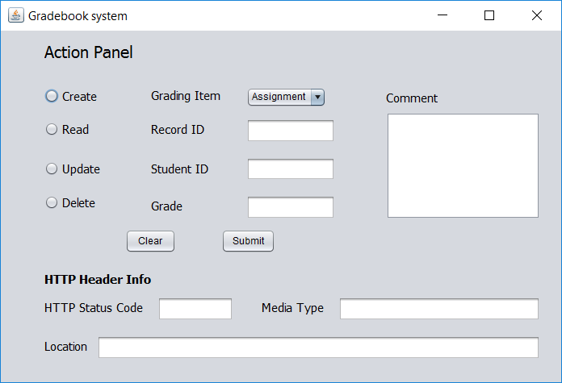

1. **The following steps will give you a hands-on operation guide on how to interact with CRUD server system to store/retrieve/update/delete a valid object**.
2. First, let’s try to **CREATE** a student grade record as shown below:

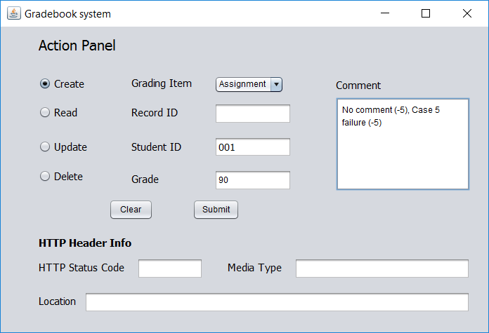

1. Now, click “Submit” will yield the following feedback info:

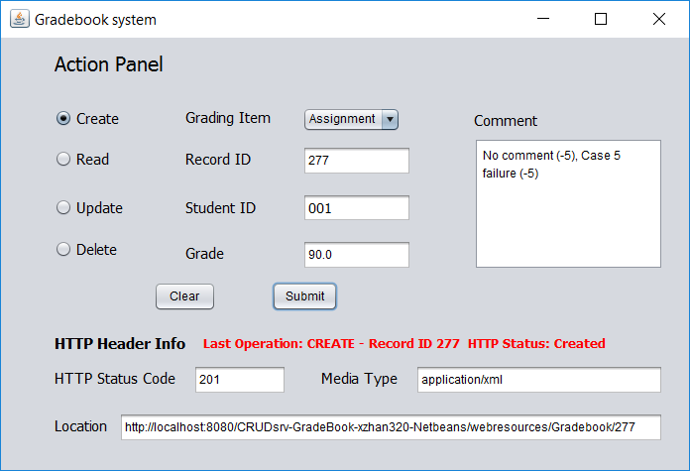

(Note: When creating the first instance of the gradebook, the CRUD server will randomly generate a record ID attached to the gradebook entries. The reason why student ID is no longer a primary key is that for each student ID the gradebook may have up to 4 grading records (Assignment, mid-term, quiz, class labs) associate with it. Thus, the student ID alone is not unique identifier but the combination of (Student ID, Grading Item) is.)

1. Now, let’s try to **READ** the record we just created. Click “Clear” to make panel tidy and type “277” in the Record ID text field.

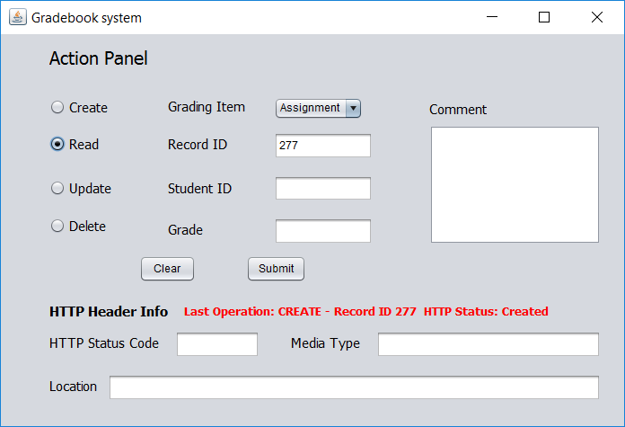

1. Now, click “Submit” will yield the following feedback info:

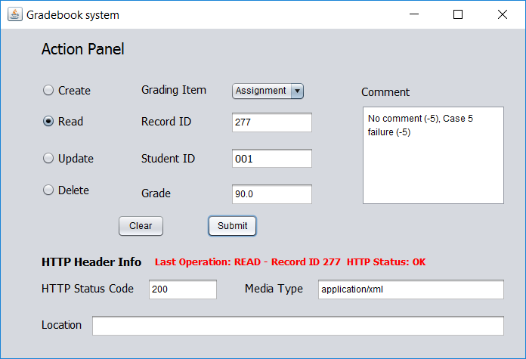

(Note: The Location filed is only populated when a Resource is created)

1. Now, let’s try to **UPDATE** the record we have created.

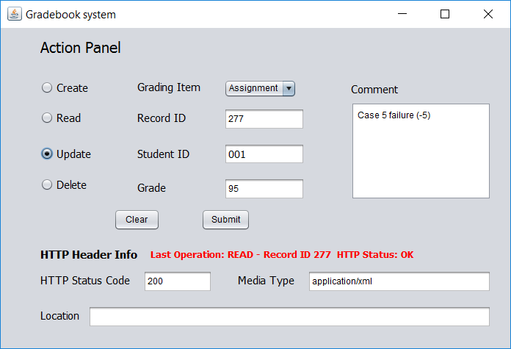

1. Now, click “Submit” will yield the following feedback info:

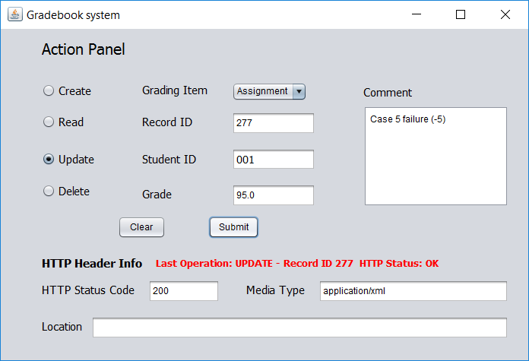

1. Now, let’s try to **DELETE** the record we have created.

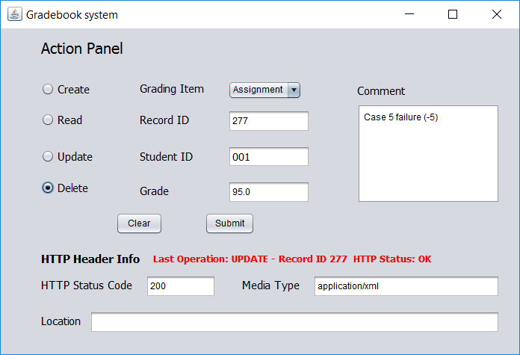

1. Now, click “Submit” will yield the following feedback info:

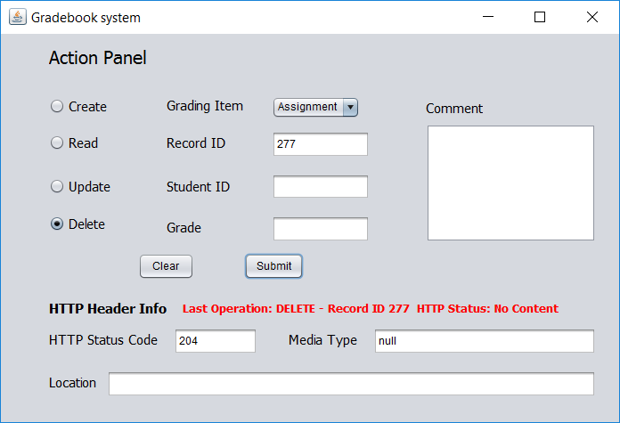

1. **The following steps will give you in-depth guide on how CRUD server system detect and handle invalid inputs**.
2. Error request handling 1: Delete a record that does not exist.

Let’s try to **DELETE** the same above record once again. Click “Submit” will yield the following feedback info:

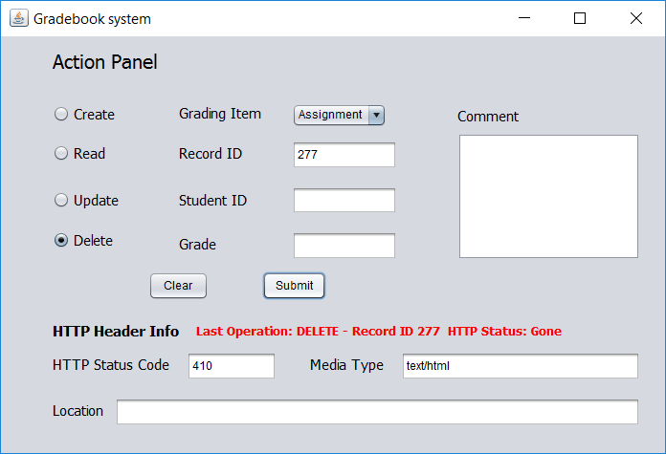

1. Error request handling 2: Read a record that does not exist.

Let’s try to **READ** a record that has been deleted. Click “Submit” will yield the following feedback info:

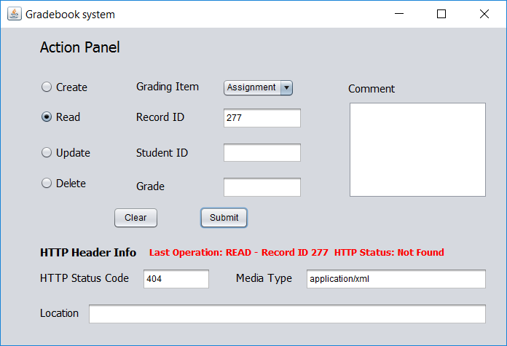

1. Error request handling 3: Update a record that does not exist.

Let’s try to **UPDATE** a record that does not exist. Click “Submit” will yield the following feedback info:

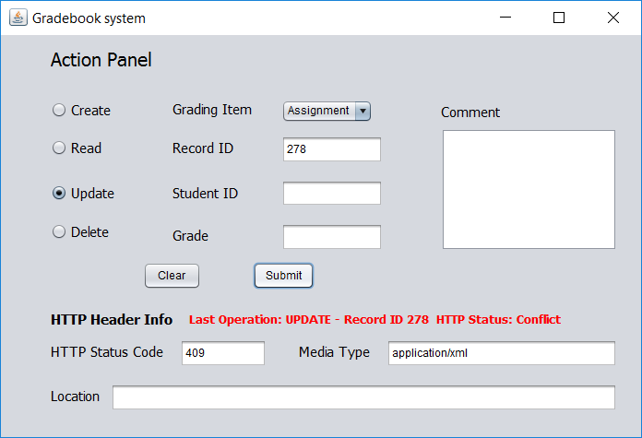

Note: The Conflict status is determined and returned by the code module below:

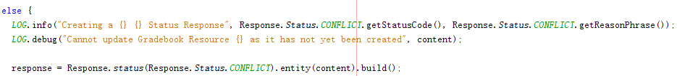

1. Error request handling 4: Create duplicate records.

First, let’s try to create a new record as shown:

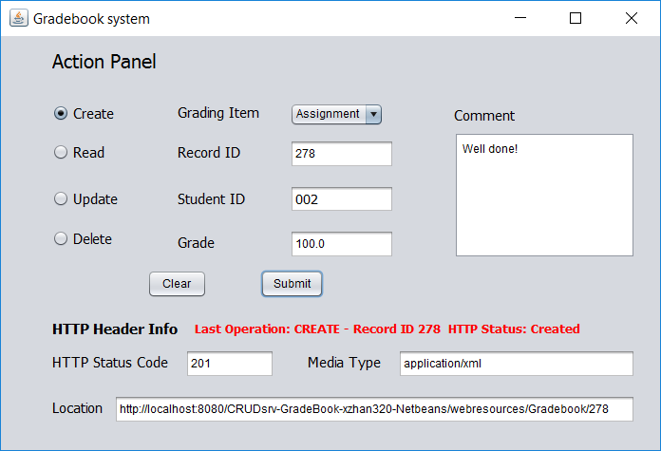

Then, if we click “Submit” once again, we will receive a Conflict Status:

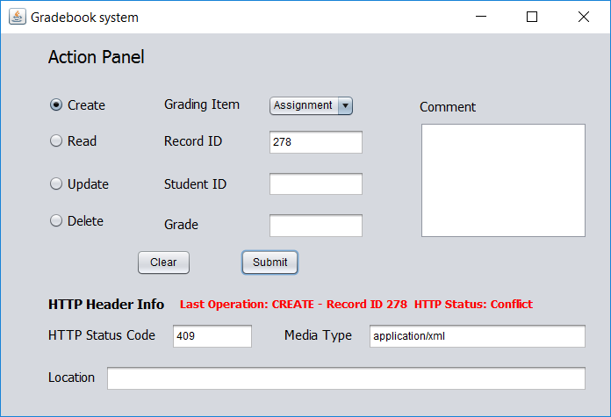

However, if we change the “Grading Item” with everything else remaining unchanged, the CRUD server will return no bad status. Instead, a new record ID will be assigned for the same student ID with different grading items:

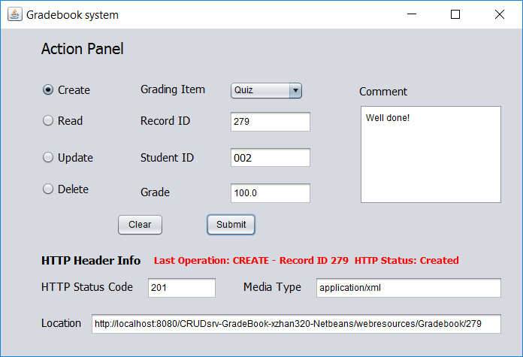

The standard of CRUD server on collision inspection is carried out by the if-statement below:

